**Experiment Number – 07**

**Aim:** Write C++ program to create a class for student to get and print details of a student.

**Objective:** To get the details of a student

**Flowchart:**

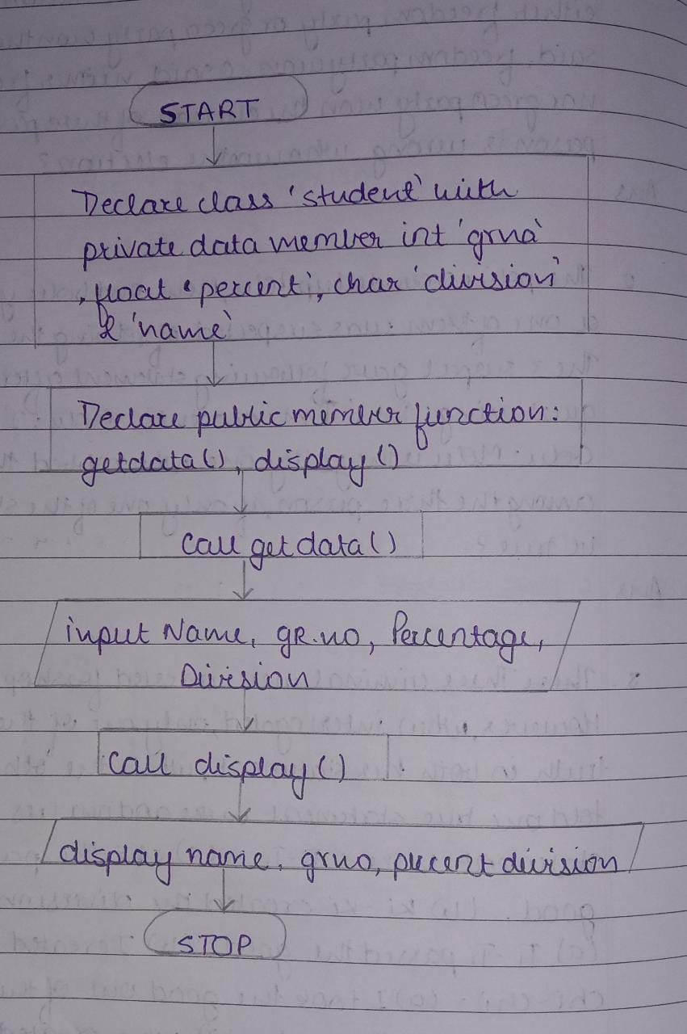

**Algorithm:**

1. Start.
2. Declare the class ‘Student’ with integer data member ‘grno’, float ‘percent’, char ‘division’ & ‘name’ under private access specifier
3. Declare Member functions: ‘getdata’, ‘display’ under public access specifier.
4. Call the function getdata() and get the following data from user.

* Name
* GR. No.
* Percentage
* Division

1. Call the function display() and display the following data.

* name
* division
* percent
* GRN no.

1. Stop.

**Program:**

# include<iostream>

using namespace std;

class student

{

    private:

    int grno;

    float percent;

    char division;

    char name[20];

    public:

    void getdata()

    {

        cout<<"Enter student details:"<<endl;

        cout<<"Enter Name:"<<endl;

        cin>>name;

        cout<<"Enter GR. No.:"<<endl;

        cin>>grno;

        cout<<"Enter Percentage:"<<endl;

        cin>>percent;

        cout<<"Enter Division:"<<endl;

        cin>>division ;

    }

    void display()

    {

        cout<<"DETAILS :-"<<endl;

        cout<<"Name:"<<name<<endl;

        cout<<"Division:"<<division<<endl;

        cout<<"Percentage:"<<percent<<endl;

        cout<<"GR. No. :"<<grno<<endl;

    }

};

int main()

{

    student s1;

    s1.getdata();

    s1.display();

    return 0;

}

**Output:**

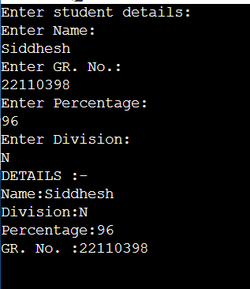

**Conclusion:**

With the help of a class student, user input values can be passed to objects of class and this property enables us to get and print details of a student.

**Submitted By:**

Name: Siddhesh Dilip Khairnar

Roll Number: 1421

PRN Number: 22110398

Division: N

Batch: N1